

**CAST AND CREW**

|  |  |
| --- | --- |
| **CAST** | |
| Emmy Bailey | Breisiedia |
| Kendall Boyd | Hippodamia |
| Ella Brumbelow | Andromache |
| Joel Chen | Menelaus |
| Caylyn Kelly | Hecuba |
| Janhavi Kulkarni | Cassandra |
| Emily Oden | Athena |
| Marty Respess | Poseidon/Talthybius |
| Aryan Tripathi | Guard |
| Kate Zeumer | Helen |
| **CHORUS** | |
| Olivia Adams | Astynome |
| Kendall Boyd | Ipodamia |
| Allie Hodges | Penthesilea |
| Madison Langton | Antiope |
| Brillele McLean | Eso |
| Alyssa McLish | Theano |
| Hiccup Seney | Chryseis |
| Shayla Swanson | Illione |

|  |  |
| --- | --- |
| Stage Manager | Maya Gaston |
| Assistant Stage Manger | Megan Bullock |
| Assistant Stage Manager | Evie Hufstetler |
| Lighting Designer | Jonthan Lease |
| Electrician | Joseph Summers |
| Projections Designer | Taylor Shaw |
| Props Designer | Danica Dilione |
| Scenic Designer/TD | Nick Ryan |
| Assistant Scenic | Kevin White |
| Costume Designer | Shelley Kuhen |
| Light Board Operator | Eva Chidi-Maha |
| Sound Board Operator | Lu Borgia |
| Wardrobe | Hannah Gray |

**CREW**

**NOTE TO AUDIENCE: The videotaping or audio and/or visual recording of this production is prohibited.**

**CAST and CREW**

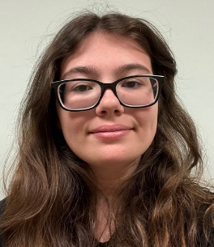Olivia Adams

Olivia Adams (Astynome) is a freshman civil engineer major at Mercer University. She has enjoyed working on this play and looks forward to future productions with Mercer Players.

Emmy Bailey

Emmy Bailey (Breisiedia) is a junior psychology major with double minors in sociology and theatre. This is her second show at Mercer, but she's been involved in theater her whole life. Emmy loves the magic of storytelling on stage and is excited to share ethos production with you!

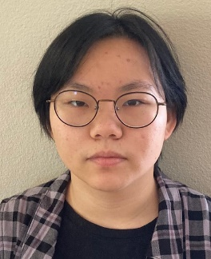Lu Borgia

Lu Borgia (Sound Board Operator) is a freshman art and media studies double major at Mercer University. This is the first production they have worked on at Mercer and they look forward to future productions with Mercer Players. Lu would like to thank their friends and family for their support.



Kendall Boyd

Kendall Boyd (Hippodamia) is a junior criminal justice and psychology double major at Mercer University. She has done theatre since childhood, but you may recognize her from, "The Opener" and "The Lightning Thief: The Percy Jackson Musical", at Mercer. She is very excited to share her hard work with the audience!

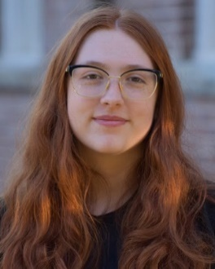Megan Bullock

Megan Bullock (ASM) is a freshman english and classical studies double major at Mercer University. She has also been ASM for “Premier Performances 2024” and “The Colored Museum” with Mercer Theatre. She would like to thank the cast, crew, and our guest director, Jeff for all of their hard work. She hopes you enjoy the show!

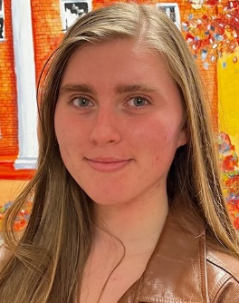Ella Brumbelow

Ella (Andromache) is a senior here at Mercer University and is majoring in psychology as well as minoring in theatre and marketing. She is very excited to be a part of this show.

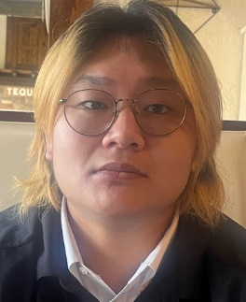Joel Chen

Joel Chen (Menelaus) is a junior history and secondary education major. He has enjoyed working on this play and looks forward to future productions with Mercer Players. He would like to thank the cast and crew for all their hard work.

Eva Chidi- Maha

Eva Chidi-Maha (Light Board Operator) is an alumna with a B.A. in psychology and spanish with a theatre minor from Mercer University. This is her seventh (and possibly last) show with Mercer, and she's excited to be a part of such a captivating show. She would like to thank the cast and crew for all their hard work in bringing it to life, especially the first time actors and crew members! And she hopes you enjoy the show!

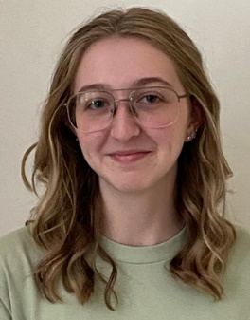Danica Dilione

Danica Dilione (Props Designer) is a theatre and media studies double major. She has been involved in theatre ever since she was a little kid, but this is her first time props designing! She has loved this opportunity and thanks the stage management team, as well as the faculty for all their help and support throughout this time. She would also like to thank all the cast and crew for helping make “The Trojan Women” happen and hopes you enjoy the show!

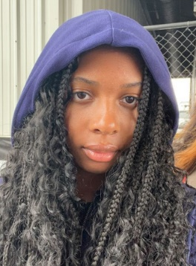Maya Gaston

Maya Gaston (Stage Manager) is a freshman biochemistry major and theatre minor at Mercer University. She has enjoyed working on this play and looks forward to future productions with Mercer Players. She would like to thank the cast and crew for all their hard work.

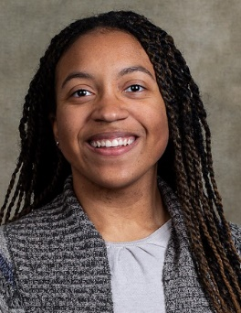Hannah Gray

Hannah (Wardrobe) is a senior pursuing an elementary education degree at Mercer University. She has almost a dozen years of theatre experience onstage and behind it and she has been a crew member in several Mercer Player productions. She is so excited to be a part of this unique production!

Jeffrey Green

Jeffrey Green (Director) served for 22 years as Professor and Chair of Theater, Communication and Media Arts at Georgia Southwestern.  A member of Actor's Equity Association since 1985, he has worked in Regional and NYC area theaters.  He served as President of the Georgia Theater Conference, and Chair of Kennedy Center American College Theater Festival.  He is recipient of a Kennedy Center Gold Medallion and a Governor's Honors Award for the Arts and Humanities.  He is grateful to his former students Nicholas Ryan, and Anthony Hand, who now serve as faculty and staff at Mercer, for their assistance in making his residency at Mercer possible.

****Penni Hartley

Penni Hartley (Administrative Assistant) is a Mercer Alumni with a B.A. in art and photography and is the Center Coordinator for Tattnall Square Center for the Arts, Art and Mathematics Departments, and the McEachern Art Gallery.

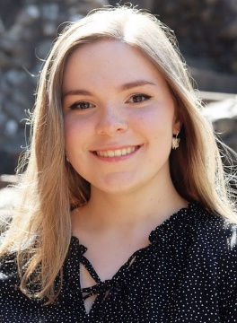Allie Hodges

Allie Hodges (Penthesilea/Fight Captain) is a junior theatre and communication studies double major at Mercer University. She has worked on various Mercer Theatre productions in the past, and this is her first performance on the stage. She would like to thank the cast and crew for all their amazing work.

Evie Hufstetler

Evie Hufstetler (ASM) is a recent graduate from Mercer University with a double major in music and theatre. She has worked on various Mercer Theatre productions such as “Rabbit Hole”, “Men On Boats”, and “The Lightning Thief: The Percy Jackson Musical”. She would like to thank her family, Danica, Taylor, and Frani for their support.

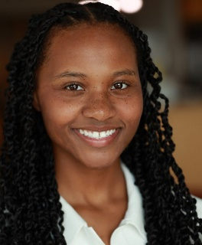Caylyn Kelly

Caylyn Kelly (Hecuba) is a senior theatre and communication studies double major at Mercer University. Caylyn serves as our Business Manager of the Zeta Pi Chapter of Alpha Psi Omega National Theatre Honor Society! You may have seen her as Miss Roj in “The Colored Museum”, Becca in “Rabbit Hole”, Eleonora Duse in “A Divine Kerfuffle”, or as Caterpillar in “Alice in Wonderland”. Caylyn also works in tv/film projects! Caylyn plans to attend graduate school to study acting professionally after she graduates in May 2025! She would love to give thanks to God, and to her family and friends for their support! She hopes you enjoy the show!

 Shelley Kuhen

Shelley Kuhen (Costume Director) This is Shelley’s 28th season as Costume Director for Mercer Theatre. She designs the costumes and is the costume shop manager as well. Her last designs for Mercer Theatre were “Premier Performances”, “Rabbit Hole” and “Men On Boats”. She also designs for Mercer Opera and her costumes were seen in their production of “Thrills and Chills” in October. Her costume creations were recently seen in Theatre Macon’s “The Wizard of Oz” and “Fences”. She wants to thank her family for their love and understanding as they’ve supported her through many crazy endeavors. She also thanks her costume shop crew for their countless hours of hard work and for their encouragement, love and laughter.

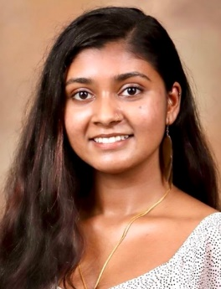Janhavi Kulkarni

Janhavi Kulkarni (Cassandra) has been a part of several Mercer Theatre productions, including "Hamlet 2020", "Eurydice", "Mercer Haunts", "12 Angry Jurors", "Men on Boats", and "Premier Performances 2024". She is very excited for everyone to see "The Trojan Women", and she thanks the cast and crew for their hard work and dedication!

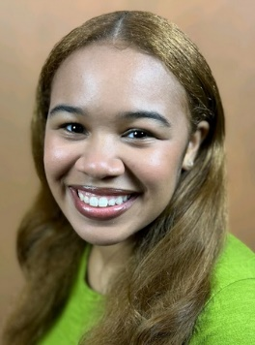Madison Langton

Madison Langton (Antiope) is a senior accounting major who has been a part of many Mercer Theatre shows, with this being one of her final shows. She wants to thank the amazing cast and crew for their hours of work to put this together; also our amazing guest director Jeff who made the entire process of the show so fun!

Jonathan Lease

Jonathan Lease (Lighting Designer) is a sophomore music and theatre double major. He has worked in technical theatre around Middle Georgia, including at MGSU, Wesleyan, Macon Little Theatre, and Mercer University. He looks forward to helping bring this show to life!

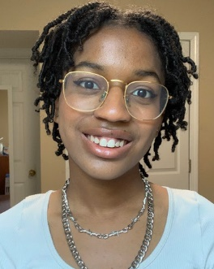Brielle McLean

Brielle McLean (Eso) is a junior marketing major with a minor in theatre. This is her fourth play at Mercer University, and she is excited to participate in more in the future with Mercer Players. Brielle would like to thank her family, friends, and the whole cast and crew for their encouragement and support.

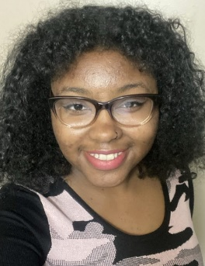Alyssa McLish

Alyssa McLish (Theano) is a freshman at Mercer. This is her second production with Mercer theatre and she wants to thank everyone involved and her family and friends. Alyssa is a dancer, actress, and singer-songwriter, whose debut studio album came out on August 30, 2024. She hopes you enjoy seeing her and her peers in “The Trojan Women”.

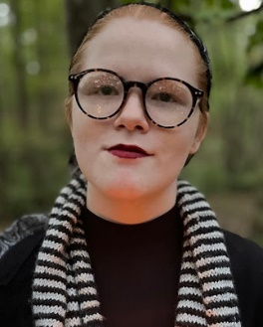Emily Oden

Emily Oden (Athena) is a biomedical engineering major at Mercer University. She enjoys being in productions and has so far only been in "Alice in Wonderland."

Marty Respess

Marty Respess (Poseidon/Talthybius) is a chemistry major who is participating in Mercer Theatre for the second time and is excited to be a part of this production. He would like to thank the cast, his family, and the crew for all their hard work, especially the tech team.

Frani Rollins

Frani Rollins (Sound Designer) is the Program Director for Mercer Theatre and an Associate Professor of Design and Technology with the Mercer University Theatre Department. She would like to thank the Mercer Players, the Mercer Theatre Program, and her family for being awesome, supportive, and inspiring people.

Nick Ryan

Nick Ryan (Scenic Designer) holds a Master of Fine Arts in Theatre: Technical Production from The University of North Carolina at Chapel Hill and received his Bachelor of Arts in Dramatic Arts- Design & Technology from Georgia Southwestern State University. Nicholas has also had the pleasure of working professionally for Georgia Stage, a theatrical rigging & drape company, The Historic Rylander Theatre in Americus, GA, Cortland Repertory Theatre, and Utah Shakespeare Festival.

Hiccup Seney

Hiccup Seney (​​Chryseis) is a fine arts major with a background in animal care. She has thoroughly enjoyed getting to fight and learn tai chi for the Mercer production of “The Trojan Women”. She hopes you enjoy the show and is very thankful for all who have helped her stand here today.

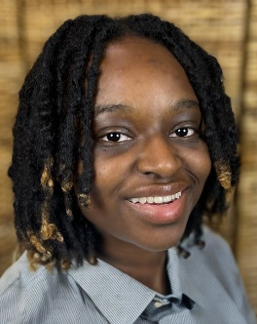Taylor Shaw

Taylor Shaw (Projections Designer) is a senior computer science and theatre major with a cybersecurity minor at Mercer University. Taylor has enjoyed working crew on several of Mercer’s productions and acting in two. Taylor hopes you enjoy the show and thanks everyone involved for their hard work and support.

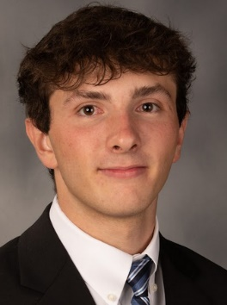Joseph Summers

Joseph Summers (Electrician) is a global health major on the pre-nursing track. He was involved in theatre in high school and is excited to get back into it. He would also like to thank all the cast and crew for their hard work. Enjoy the show!!

Shayla Swanson

Shayla Swanson (Hector/Illione) is a senior marketing and management double major at Mercer University. She has been in multiple Mercer Theatre productions such as “Hamlet”, “Premier Performances”, “Mercer Haunts”, ”Alice in Wonderland”, “A Divine Kerfuffle”,  “Men on Boats”, and “The Colored Museum”. She is excited to be a part of this show and would like to thank the cast and crew for all of their hard work. She hopes everyone enjoys the show!

Aryan Tripathi

Aryan Tripathi (Guard) is a senior supply chain management major and a sports marketing minor. He would like to thank his family and friends for their support.

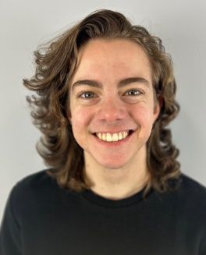  
Kevin White

Kevin White (Assistant Scenic Design) is a senior, graduating with degrees in sports marketing & analytics and media studies. He has worked as a Theatre Shop Assistant for 4 years, building sets for each of the Mercer Players productions within that time. His love for technical theater, fostered through high school and college, began when he saw a PlayMakers production of “The Little Prince” and spent more time daydreaming about the catwalks than paying attention to the show.

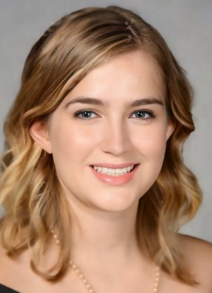Kate Zeumer

Kate Zeumer (Helen) is a sophomore english major and theatre minor. She has previously appeared in “Eurydice” as Gravestone, Kimberly in “Mercer Haunts”, and worked on wardrobe for the “Premiere Performances 2022”. She would like to thank the cast and crew for their dedication in making this fantastic production come to life!

