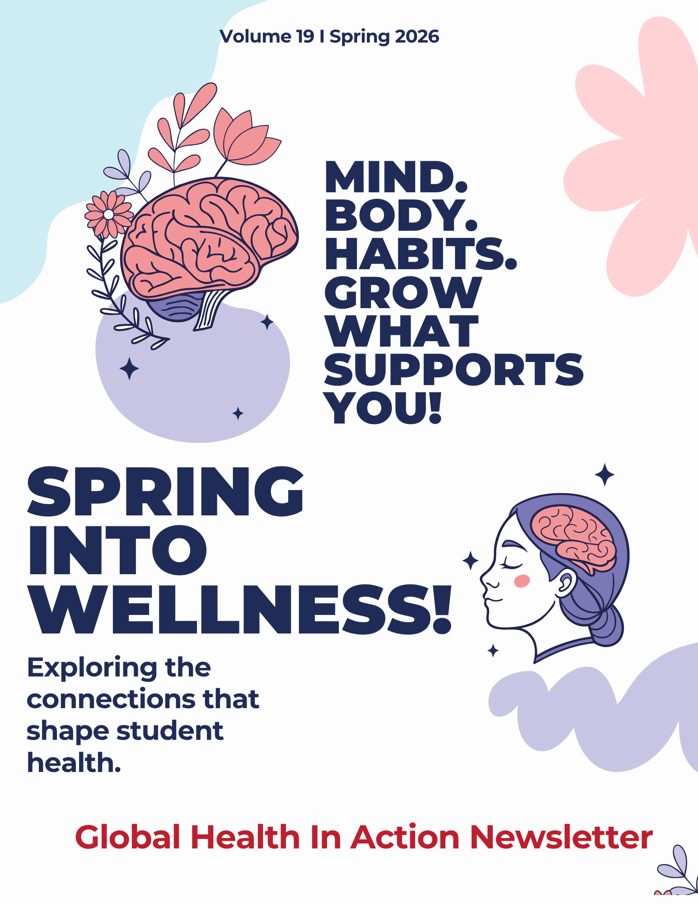

Wellness: An interconnected system that shapes student’s lives.
-By Keslyn Billings
College is a time in a person’s life where they are often on their own for the first time ever. That new found independence can be incredibly exciting, but also equally scary. You are left with a lot of questions, and often times few places to receive any answers. There are many factors that affect a student’s ability to adjust to college and our goal with this newsletter is to provide some comfort, support, and information that is easily accessible.
This edition will examine college student health as an interconnected system. Rather than treating health topics in isolation, articles will explore how mental health, sleep, stress, nutrition, sexual health, and health literacy intersect and shape students’ academic performance, relationships, and overall well-being.

Table of contents

Table of Contents
Mental Health: What is it and how do we live with it? 4
Let’s Talk About it: Sexual Health In College 8
Sleep Health: Running on empty? 11
Academic Stress: Is it Normal? 16
What is Health Literacy and how does it affect us? 19
Beyond The Plate 22

Mental Health: What is it and how do we live with it?
-By Hannah Knight
Mental health is a buzzword in today's culture. But what is mental health? The World Health Organization defines mental health as a “state of mental well-being that enables people to cope with the stresses of life, realize their abilities, learn and work well, and contribute to their community.” What does that really tell us? Essentially, mental health is mental well-being that allows people to live well. That leads to another question: What is mental well-being, and how does one achieve mental well-being? To answer these questions, let us consider what contributes to mental health.
We have all experienced days and seasons when our mental health bleeds into every crevice of our lives, affecting our relationships, physical health, emotional well-being, and daily tasks. On the other hand, we also have experienced when challenging life situations, in our relationships, physical health, emotional well-being, and daily tasks, affect our mental health. Mental health is involved in every aspect of life, and every aspect of life affects mental health. It is impossible to separate mental health from everyday living, and having good mental health is important to overall well-being.
According to the World Health Organization, a billion people globally experience mental health issues. Clearly, disruptions in mental health are common to human existence. The goal is not to avoid challenging life situations or aim for perfection in our mental state, but to respond and cope to whatever life throws at us in a healthy way. This newsletter talks about mental health in the university setting. Now, do not get me wrong, college is a wonderful time to explore and develop as humans, try new things, talk to new people, and establish who you want to be. However, adjusting to college is hard, and experiences in college can be challenging. There are a lot of big changes and uncertainty, all of which are common and normal. Remember, mental health challenges affect everyone at some point in their life – you are never alone in the challenges you face.

1 in 7 people globally suffer with some form of mental health.
Let’s briefly go over some areas that can affect mental health. The body has many moving parts, from sleep to diet to exercise, that affect mental health. While the vast quantity of physical contributions to mental health can be overwhelming, it also provides a variety of ways to increase mental health through small changes. For example, going to bed consistently can dramatically increase mental well-being, which is a rather small lifestyle change with big impacts.
Another big factor that affects mental health is one’s identity. Where does identity begin – at the family. Upbringing heavily influences identity, self-talk, and response to emotions. Further, identity is influenced by cultural, ethnic, national, and historical contexts. What does your culture say about mental health? Does it encourage discussion or suppression of mental health problems? It is important to note that nothing is permanent – it is good to acknowledge the influences of individual upbringing, but individual choices can create change, and you are not bound to the choices of others. If your family never talked about mental health, but you want to – you have the power to change your narrative.
Now we cannot talk about mental health without talking about thoughts. The brain is a great tool for human success; however, if left unchecked, our thoughts can control us instead of us controlling our thoughts. Intrusive thoughts are real, and it is important to acknowledge our intrusive thoughts. Similarly, unchecked emotions can hinder our brain's processing of
information, clouding our judgment and negatively affecting our mental health. It is important to acknowledge emotional stressors, such as stress, grief, and procrastination. To tackle intrusive thoughts and emotions, first ask yourself where they come from – the media, yourself, or other people? Next, determine whether to keep the thought or emotion by asking if it is true or helpful. If needed, you can replace the thought or emotion with something positive or act on it. To ensure mental-wellbeing, we must be in charge of our thoughts and emotions.
Relationships – human connection is fundamental to human existence. We all know that relationships are never easy and always come with some sort of emotional baggage, which can cause stress and anxiety. Community and connection are essential to good mental health – you do not need hundreds of friends, but you do need genuine connection and people to live life with. Therefore, we must figure out how to navigate relationships in a healthy way that does not take a toll on our mental health. Boundaries are important, and knowing how to communicate your thoughts and emotions in a healthy way is crucial to maintaining healthy relationships and good mental well-being.
Throughout the remainder of the newsletter, we will explore different topics that contribute to mental health and well-being and provide you with resources to better your personal mental well-being. How do you cope with all these factors that influence mental health? First off, coping is individualized to each person and looks different for everyone. What works for one person might not work for you. The goal is not perfection but to cope with the daily stressors of life in a healthy way to boost mental-wellbeing. The best place to start is reflection. I challenge you to deeply consider what areas in your mental health need some work and then to try some of the tools listed here. However, also offer yourself some grace, as this can be a lot of information and change does not happen overnight – it takes discipline and consistency over a long period of time. Most importantly, some issues you face need outside support, and it takes courage and strength to acknowledge that you need help. Please seek out assistance if you need it.

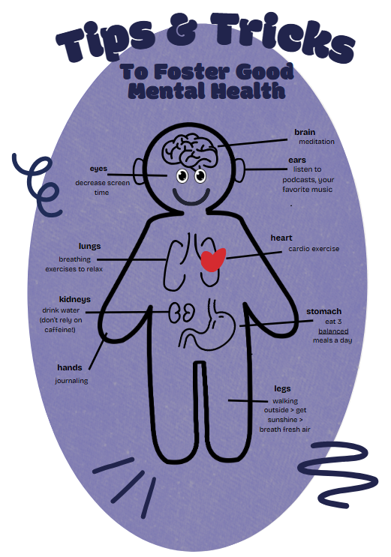

Let’s Talk About it: Sexual Health In College
-By Keslyn Billings
College students talk about sex all the time, whether it is joking with friends or discussing an episode of a show like Heated Rivalry. But while sex comes up casually in everyday conversations, sexual health is still often seen as awkward or uncomfortable to talk about in a more serious, educational way. Even though it may feel uncomfortable, sexual health is an important topic, especially for college students who are in a new environment with more independence, which can increase both opportunities for sex and potential risks.
What is sexual health? The World Health Organization describes sexual health as a state of well-being that involves safe and respectful sexual experiences, supported by access to accurate information and quality care and resources. This includes topics like sexually transmitted diseases (STDs), contraceptives, consent, sexual violence, and pregnancy. Sexual health is also closely connected to overall mental well-being. It is not just about protection. It is also about understanding your boundaries, your comfort, and your desires.
Sexual communication is a very important part of sexual health. A lot of times, conversations or lectures only give a basic overview of consent without going into detail about how communication plays a role in building healthy relationships. Consent requires ongoing communication.
Just because you are in a relationship with someone, or have been intimate before, does not mean there is automatic or permanent permission for sexual activity. In order to have healthy sexual relationships, you have to be able to communicate openly with your partner, checking in, asking about their likes and dislikes, and respecting their boundaries.
If you have taken UNV 101, you have probably seen the “consent and tea” video. Not everyone wants tea all the time, and that is okay. Someone might want tea one day and not the next, and that choice should always be respected, regardless of the relationship.
There are also sexual health resources available on campus. Mercer students can access the Campus Health Center, which provides services like STI testing and birth control, with the exception of IUDs and Nexplanon.
Another great resource is SGA’s Wrap It Up Wednesday, an event held multiple times each semester in the Connell Student Center. At this event, students can learn about safe wellness practices, STDs, and contraceptive options while also receiving resources such as condoms, dental dams, and Plan B.
Why is this an important topic to include in a college wellness newsletter? Not having access to accurate sexual health information and resources can impact both academic success and overall mental well-being. While it may feel like an uncomfortable topic, college is a time when many students are forming their understanding of relationships, boundaries, and health. Reducing the stigma around sexual health conversations is important because it allows students to make informed decisions, protect themselves and others, and build healthier relationships.


Nearly 1 in 2 new STI cases occur among ages 15–24.
Out of 10 people with an STI, about 5 of those people are between the ages of 15 and 24.
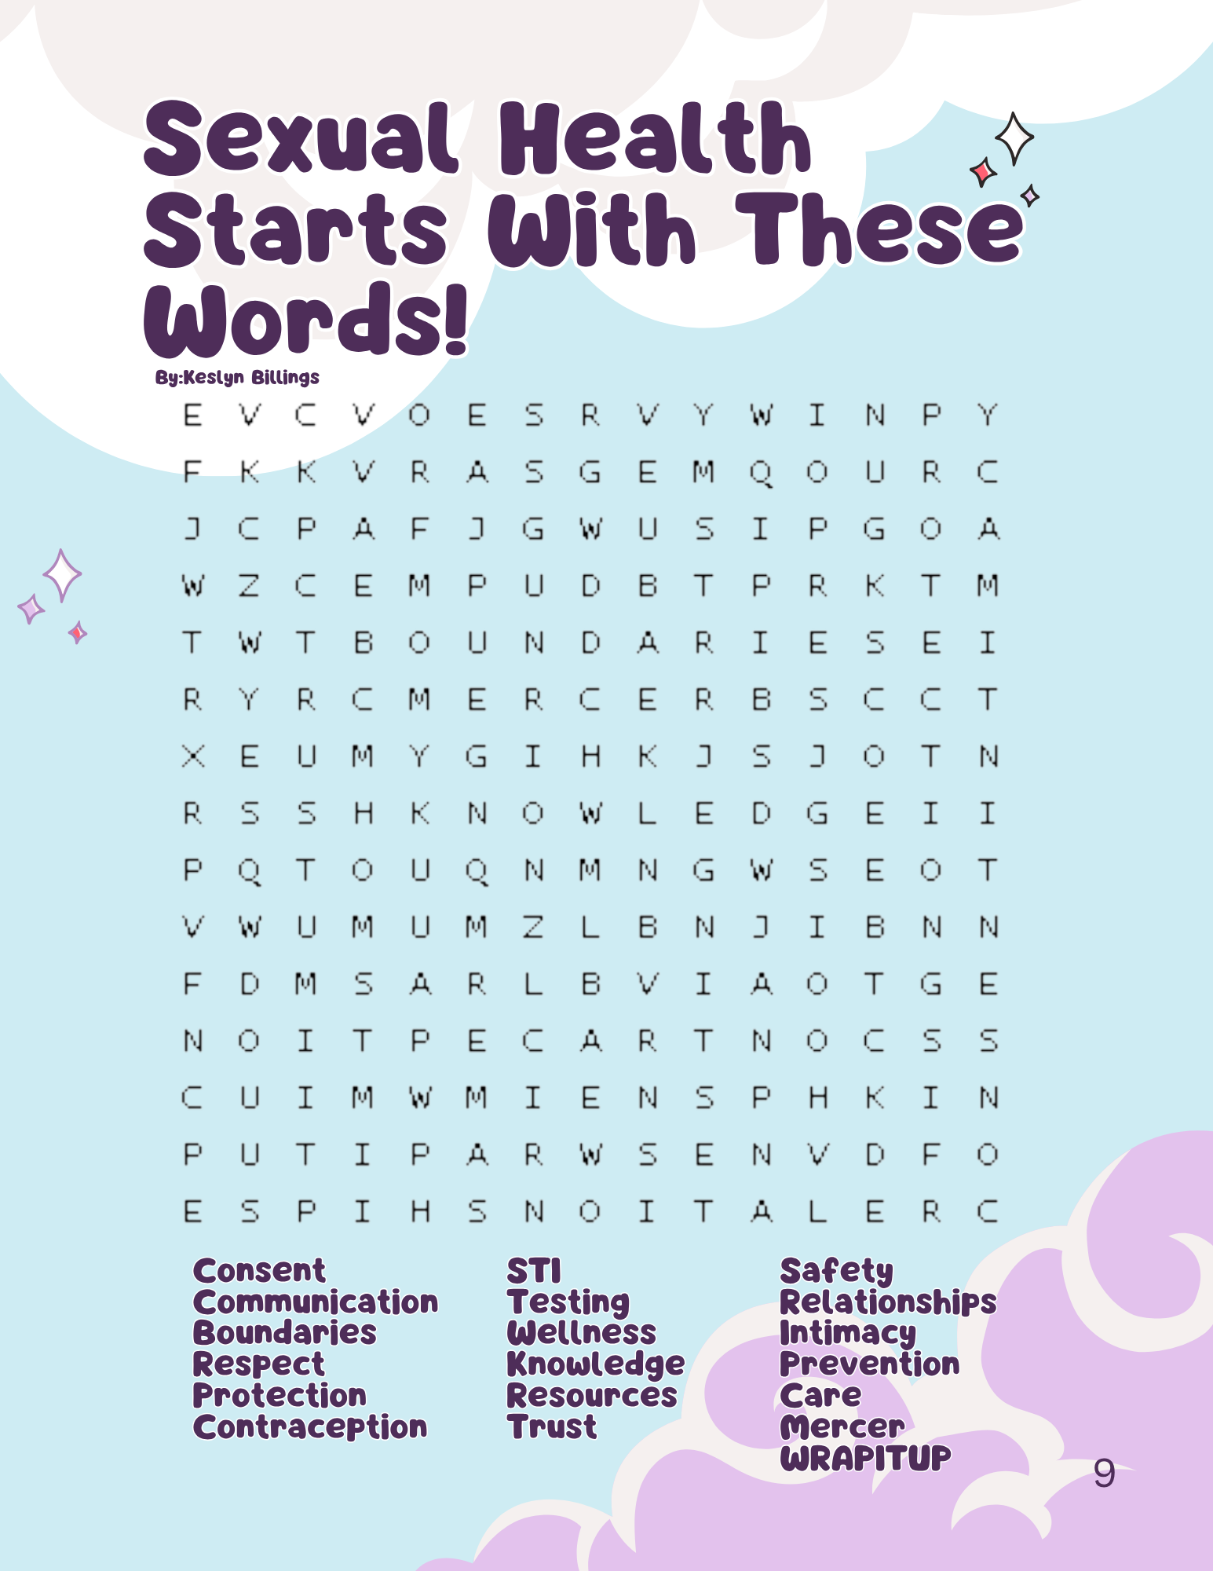

Sleep Health: Running on empty?
-By Gianna Richards
In today’s fast-paced academic world, the price of success is often measured in how many late nights, early mornings, and a shrinking amount of sleep. Far from being uncommon, chronic sleep deprivation in college has become a significant public health concern. “Sleepiness is defined as the inability or difficulty in maintaining alertness during the major wake period of the day, resulting in lapses into drowsiness or sleep”.
“Sleep deprivation is defined as obtaining inadequate sleep to support adequate daytime alertness”. Sleepiness and sleep deprivation are caused by a plethora of factors and can cause negative results. What is more common is that students experience chronic partial sleep deprivation, where they regularly obtain some sleep, but not enough to satisfy their biological needs. To fully understand the seriousness of the issue, it is critical to first examine why sleep plays such a vital role in the cognitive, emotional, and physical functioning of college students.
The importance of adequate sleep in the student-age population cannot be overemphasized enough. It can have direct ties to issues in overall immune system health, decreased energy levels, and lack of memory consolidation. Ongoing sleep deprivation has been linked to heightened stress and anxiety. When students do not get sufficient sleep, their ability to concentrate, process information, and think critically becomes impaired, which can subsequently lead to negative academic performance.
Proper sleep hygiene is a good habit to develop because it influences both mental and physical levels of the human body. Constructing a healthy sleep routine can increase students' capacity to perform at heightened academic peaks and a balanced level of mental and physical equilibrium. Young adults are generally recommended to obtain about seven to nine hours of sleep per night to support optimal cognitive and physical functioning.
Unsurprisingly, research states that students typically fail to meet this threshold. The studies also indicate that students often accumulate a deficit of sleep during the week and attempt to “catch up” over the weekends. This pattern of chronic partial sleep deprivation leads to disruptions in the human circadian rhythm. Over time, it has been shown that insufficient sleep is associated with factors such as lower academic performance, mood disorders, and increased vulnerability to a compromised immune system.
While students believe they can function well on limited sleep, evidence shows that consistently getting enough rest is essential for staying alert and performing at their highest level throughout their educational journey.
In efforts to compensate for inadequate sleep, students often consume alternatives in hopes that they will recreate the same effect of a full night's rest. These alternatives include energy drinks, caffeine, and even non-prescribed medications to remain alert. While these substances may increase alertness temporarily and reduce feelings of fatigue, they will never be able to replace the restorative process that occurs during natural sleep. Instead, these stimulants can mask underlying exhaustion, delay sleep onset, and further disrupt biological circadian rhythm.
This creates a discombobulated circadian rhythm, in which students become reliant on these stimulants to be a functioning student during the day and struggle to sleep at night. Over a prolonged period of time, a continuation of this pattern can lead to a worse state of sleep deprivation. Since the body requires stability of the physical and mental aspects of the body, interrupting the critical rejuvenation process of natural sleep can lead to a plethora of health problems.
Health experts generally recommend that adults consume no more than 400 milligrams of caffeine per day, which is roughly equal to four cups of coffee. Yet most energy drinks include levels of 200 or more milligrams of caffeine in only one serving size. Exceeding the recommended amounts of caffeine can lead to an increased heart rate, jitteriness, and elevated blood pressure. This caffeine often stays in your body longer than initially intended, and the results leave students in a conflicting cycle. The cycle entails using caffeine to combat daytime fatigue, then struggling to fall asleep due to overstimulation.
Research consistently demonstrates that insufficient sleep impairs memory, concentration, mood regulation, immune function, and overall energy levels. While students often attempt to compensate with caffeine or other substitutes, these strategies fail to replace the restorative benefits of natural sleep and may further disrupt healthy patterns. Given the widespread and measurable impact of sleep loss, both students and institutions must take proactive steps to prioritize sleep health. By promoting consistent sleep habits, reducing reliance on stimulants, and fostering campus environments that value rest, colleges can support student success in both the classroom and beyond.
In summary, sleep is a critical determinant of academic performance, mental health, and physical well-being among college students. Despite clear recommendations that young adults obtain seven to nine hours of sleep per night, many students experience chronic sleep deprivation due to academic pressures, irregular schedules, stress, and reliance on stimulants.

- Recommendation of sleep per night from the CDC:
  - Adults (18–25): 7–9 hours
  - Teenagers: 8–10 hours

- What has been the statistic from CDC + studies:
  - Average adult sleep: ~6.1–6.5 hours
  - College students: often 5–7 hours
  - Many report less than 6 hours during exams
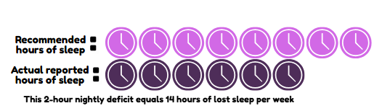
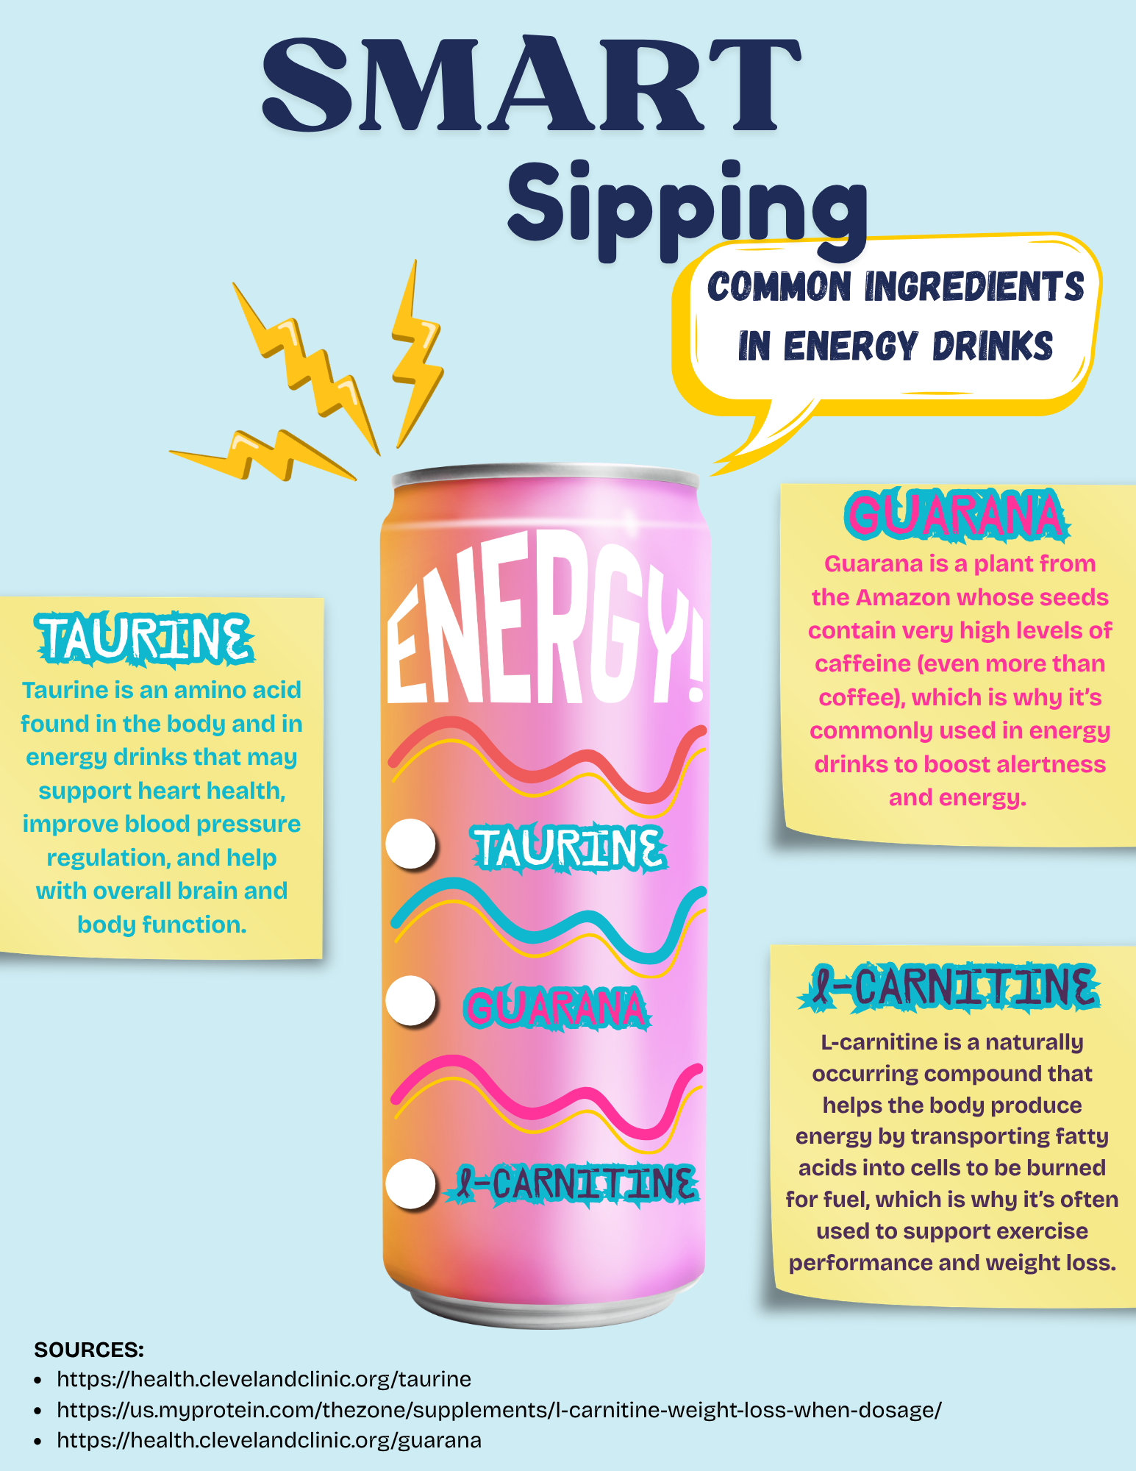
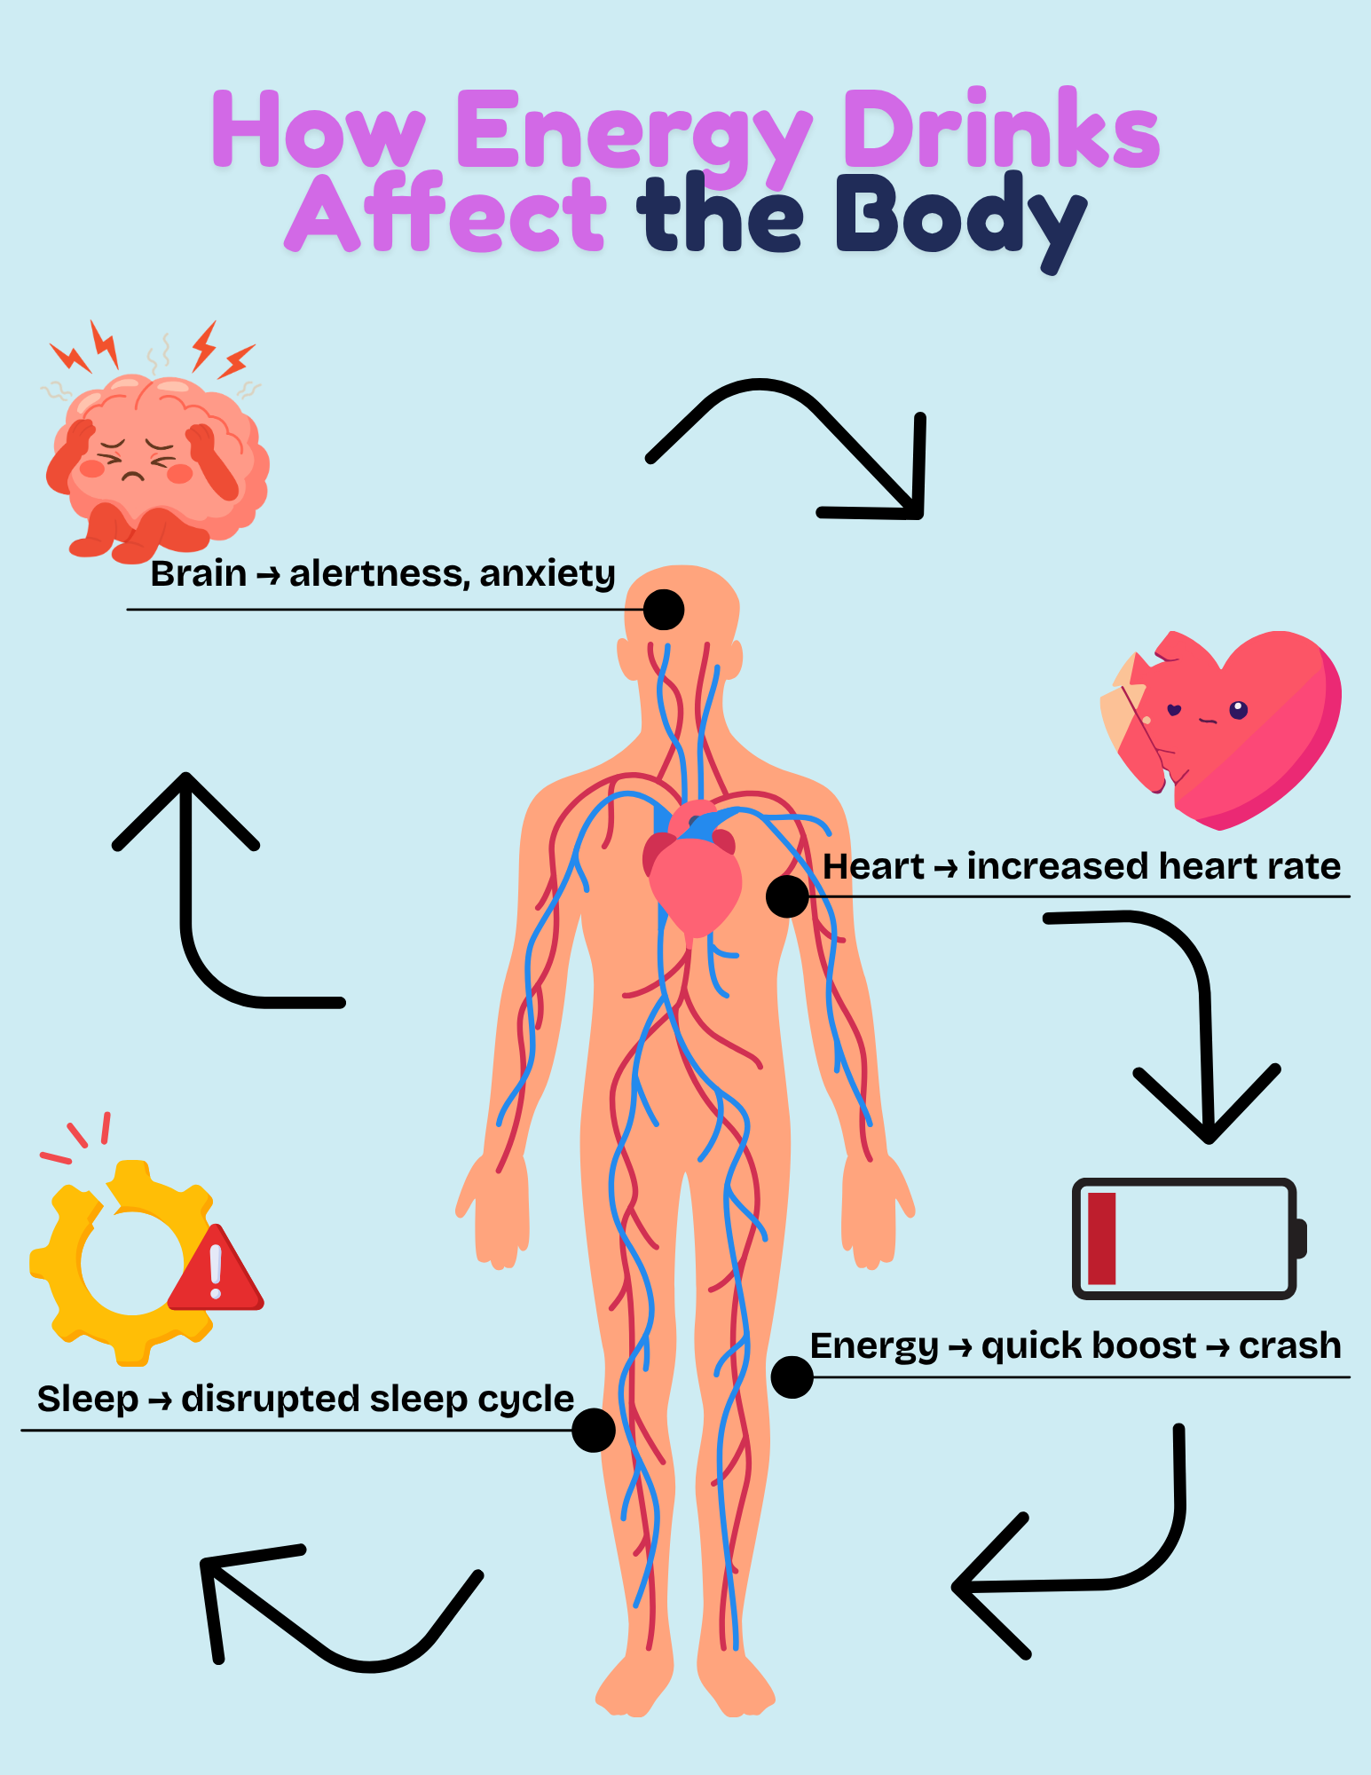

Academic Stress: Is it Normal?
-By Reese von Nordheim
While college can be an exciting, transformative period, it also comes with high academic and social expectations from peers, professors, family, and yourself.
It wouldn’t be absurd to say that stress is part of the college experience. The way you respond to stress, however, can completely shape your performance. When stress is prolonged, it can lead to burnout – a state of emotional exhaustion, reduced motivation, and disengagement from academic work. Research suggests that burnout is not simply the result of heavy workloads, but rather the product of chronic, unmanaged stress. But don’t worry, reducing academic burnout is actually simpler than you’d think.
One major contributor to burnout is sustained academic stress. Although moderate stress can enhance focus and performance, excessive stress negatively impacts concentration, emotional stability, and overall functioning. As discussed by Mia Nosanow in The College Student’s Guide to Mental Health, stress becomes harmful when it is chronic and overwhelming, often leading to symptoms such as fatigue, irritability, and difficulty concentrating. This is even more noticeable when students perceive demands as exceeding their coping abilities.
Another important factor is the imbalance of effort and reward, which occurs when students perceive that their academic efforts are not adequately rewarded.
When students feel that their hard work does not translate into meaningful outcomes, their confidence declines, which can ultimately reduce motivation and increase emotional exhaustion.
In addition to cognitive and emotional factors, physiological factors such as sleep quality play an important role in how you and your body respond to stress and burnout. Research by Ali Zakiel demonstrates that poor sleep quality contributes to higher levels of perceived stress, which in turn leads to greater academic burnout. Sleep is a major factor in a student’s ability to manage stress.
Similarly, physical activity has been shown to improve mental health outcomes. 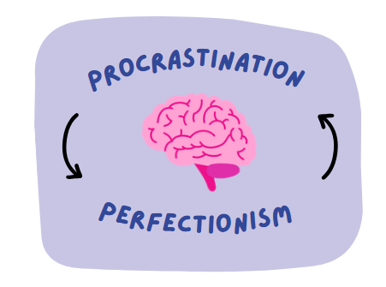
According to Yile Liu, regular exercise reduces academic stress and improves sleep quality, both of which contribute to reducing emotional and mental fatigue. Thinking patterns such as perfectionism and procrastination further worsen academic stress. Perfectionism involves setting unrealistically high standards and equating self-worth with performance. This mindset often leads to increased anxiety and fear of failure, which can hinder productivity and contribute to burnout. Procrastination, closely related to perfectionism, can be better understood as a poor emotion regulation strategy instead of a time management issue. It is common for students to delay tasks to avoid discomfort, but this avoidance ultimately increases stress and creates a cycle of disappointment.
As in the graphic above, procrastination is a cycle, not a singular occurrence. Reducing academic stress and academic burnout can be done in just a few steps.
One effective strategy is breaking tasks into smaller, more manageable parts, which can reduce feelings of overstimulation and discomfort. Fighting perfectionism can also prevent emotional exhaustion. Remember to recognize that getting the assignment done is more important than making it perfect, and that your academic performance doesn’t define your worth. Doing your best in the moment is what matters. Improving sleep and engaging in physical activity are also good choices, as both can alleviate stress and improve motivation.
Finally, students benefit from learning to address stress directly rather than avoid it. Techniques such as mindfulness, self-forgiveness, scheduling, and seeking social support can help regulate emotions and prevent stress from escalating into burnout. Procrastination is normal, but you don’t have to let it control you. Remember that sometimes reaching out is the first step.

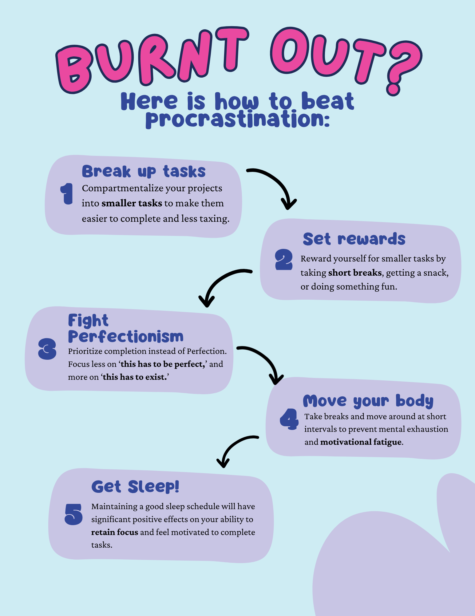

What is Health Literacy and how does it affect us?
-By Tamara Cime
In this edition, we talked about many different factors that may impact college students and their health. All of these topics, ranging from sexual health to managing academic stress, can all fall under one umbrella called “health literacy”.
Health literacy, coined in the early 1970s, addresses an individual’s ability to utilize and access health information and services to make informed decisions about their well-being. As my co-authors have explored in depth, more often than not, there is a gap in understanding one’s health in college. This can be due to many factors, but one of the most notable is probably the demanding pace of college life. Or simply not being educated on these topics is also a big factor in the health literacy of college students.
One of the particularly concerning parts about low health literacy in college students is the fact that most students have not been given the tools to properly navigate the tricky American healthcare system. For most, college is the first introduction that we have to the world of healthcare independently. Before college, most students’ parents and guardians would manage appointments, medical decisions, and insurance. Without the previous support from parents and guardians, the complexity of understanding insurance policies and the purpose of a co-pay is daunting for many students. Due to a combination of all of these factors, we see students delaying care until they are really sick or begin to rely on the internet or social media for their diagnoses and treatment. Though this is convenient in the moment, in the long run, warning signs may go undetected, causing conditions to be exaggerated.
Low health literacy rates in college students can also contribute to increased anxiety in medical settings, making students less likely to ask questions or advocate for themselves during appointments. Without the support of parents, this anxiety can prevent effective communication between the patient and the provider. along with a misunderstanding of proper treatment and their diagnosis.
Health literacy isn’t only about a deep understanding of the healthcare system. Proficient health literacy can be built by taking care of your body by eating well, having good sleep hygiene, and good stress management strategies. A key part of building strong health literacy allows individuals to recognize how they may be having problems and adopt effective practices, which in turn significantly improves mental and physical well-being.
As mentioned earlier, the hectic nature of college life causes negligence of both physical and mental health. Proper health literacy enlightens college students to the adverse effects of eating nothing or staying up late, and cramming. Being more health literate also gives the tools needed to combat misinformation and be properly informed.
You may be asking, “So what?” or “What should my next steps be?” After reading this edition of the Global Health in Action newsletter, you are actively improving your health literacy, and you are now equipped with the tools you need to be more health literate. The question I should ask you now is, how will you apply what you’ve learned to your life?
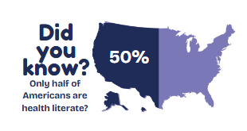
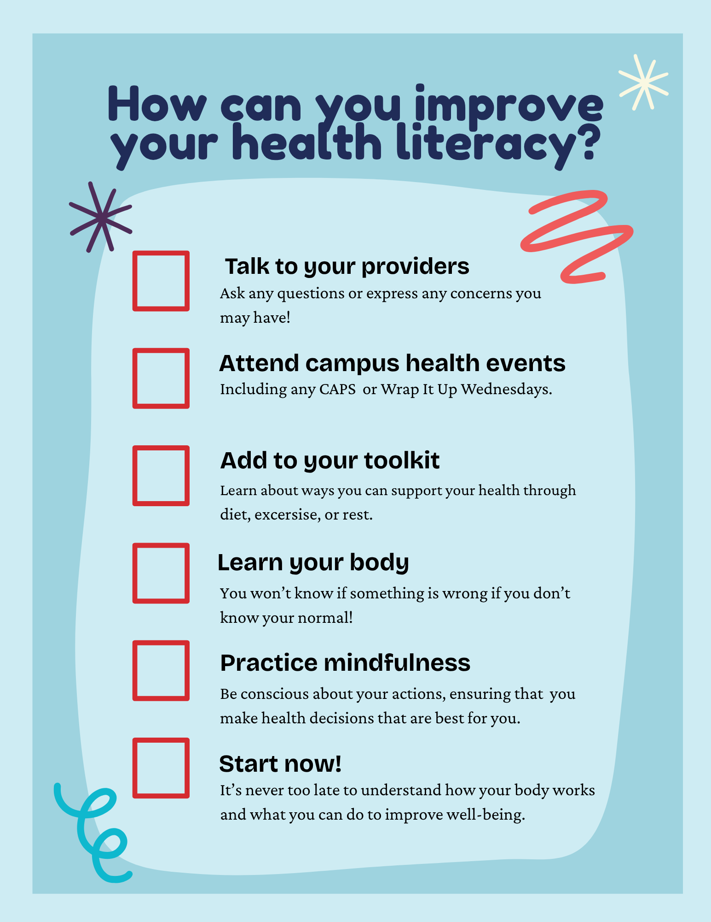

Beyond The Plate
-By Harrison Wolbert
Life in college is tough. Students are constantly strained by both time and money, which leads to high stress and sometimes risky lifestyle choices. On top of that, many students are also dealing with malnutrition as part of their college experience.
Unfortunately, despite tons of data supporting this, it still seems like many people don’t fully understand how serious malnutrition among college students really is. Some of the reasons this issue is overlooked comes from misunderstandings about diet and what malnutrition actually means, as well as the fact that the causes of malnutrition in college students can be somewhat subtle.
Importantly, malnutrition is very different from undernutrition. While undernutrition describes a lack of food overall, malnutrition is more closely tied to not getting the right kinds of foods or a balanced diet. Most students in the United States have seen nutrition charts like MyPlate before, but usually only in passing, whether in a high school health class or on the way to the cafeteria. Because of this, many people misunderstand nutrition and assume they are eating fine, when in reality their diet may be unbalanced. So, while lack of awareness is one important factor, what are the causes?
The sources are a bit more complicated. One major factor is that many college campuses are essentially “food deserts.” This term refers to places where it is difficult to consistently access not just food, but nutritious food that supports overall health. Many campuses have limited options that, when combined with busy student schedules, result in poor eating habits.
One of the biggest reasons why nutrition matters so much is its impact on mental health. Many people understand how diet affects physical health, but fewer recognize its connection to mental well-being. There is extensive research showing how harmful malnutrition can be for college students, with links to higher rates of depression, anxiety, and stress, as well as lower academic performance. Because college students are already more vulnerable to mental health challenges, this issue deserves even more attention and should be a strong motivator for change.
When it comes to solving problems like food insecurity, it is difficult to make simple recommendations. Large, systemic problems often require institutional solutions. However, there are still meaningful steps individuals can take to improve their own nutrition, and it is important to be aware of them.
The most important place to start is awareness. Nutrition is not a one-size-fits-all approach and is deeply personal. A good first step toward healthier eating is paying attention to what you eat and how it makes you feel. Taking control of your diet is not always easy, but it is important. If you find yourself struggling to stay consistent, try involving a friend. While improving your nutrition is a personal journey, it does not have to be a lonely one.
Overall, college students are uniquely susceptible to and affected by food insecurity and malnutrition. While larger institutional changes are needed, there are still practical steps students can take in their daily lives. Being intentional about what you eat can improve both physical and mental health, which can also support academic success. Even though life can feel overwhelming, focusing on nutrition is one way to better prepare your body for the stressors of college life.
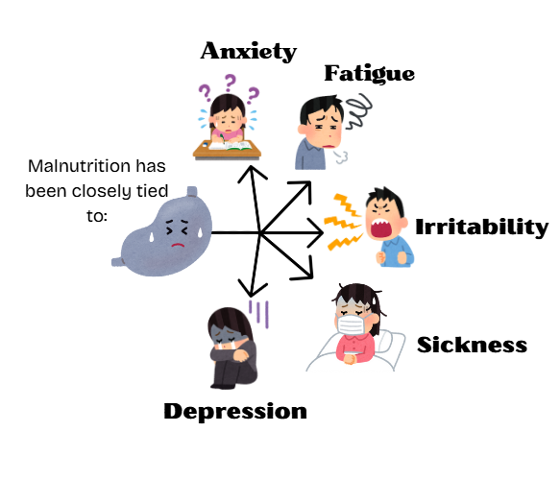

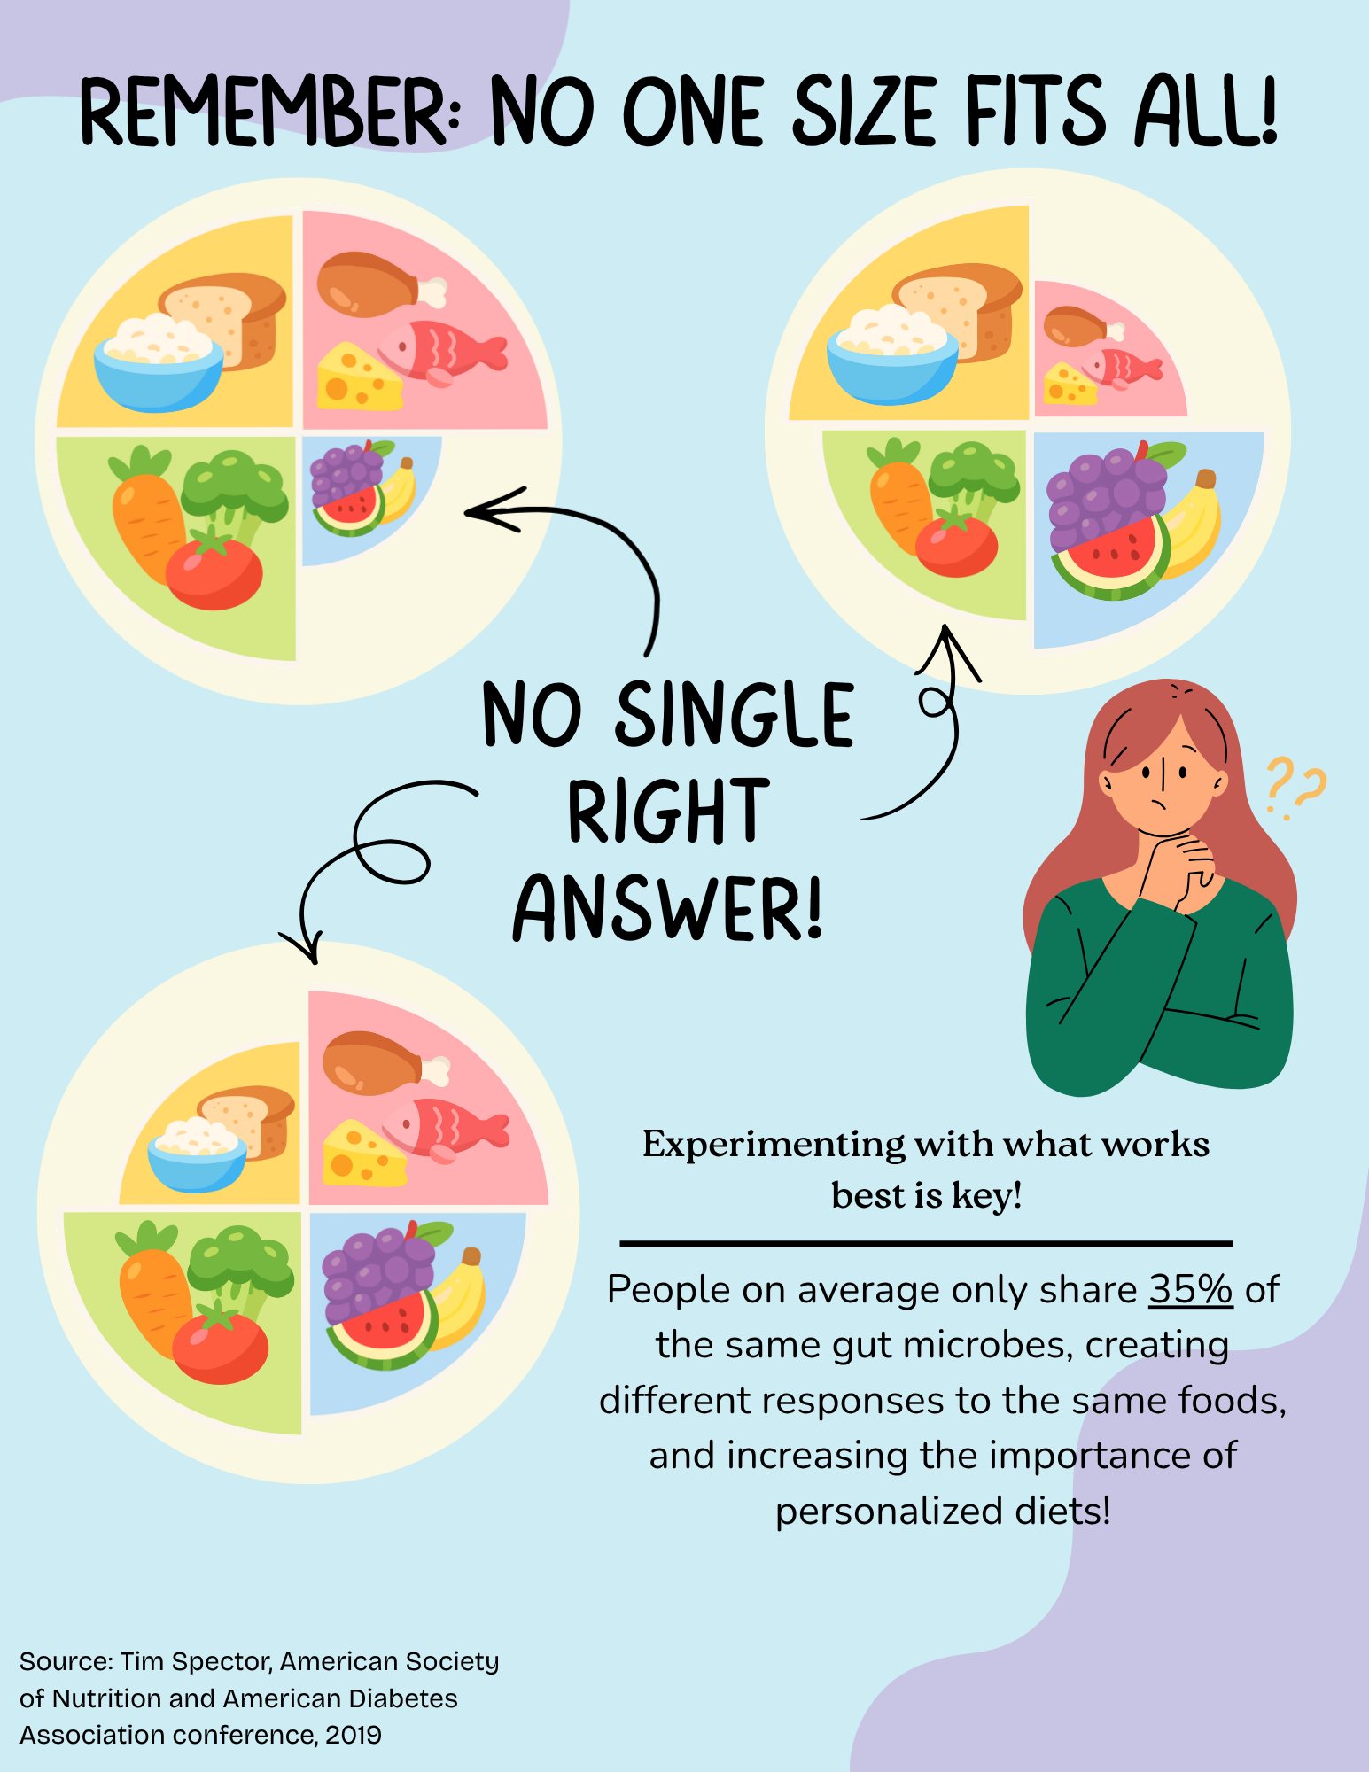

Acknowledgments
We would like to thank the International and Global Studies (IGS) faculty for their continued support.
Special thanks to:
Dr. Chinekwu Obidoa
Founder and Faculty Advisor

Dr. Amy Nichols-Belo
Associate Professor and Chair of the Department of International and Global Studies

Dr. Lauren Dodaro
Assistant Professor

Dr. Ryan Tokarz
Assistant Professor

Dr. Rachael Goodman
Assistant Professor

